Mermaid code for ER Diagram

**erDiagram**

    Vehicles **||--o{** Tires : has

    Tires **||--o{** Logbooks : records

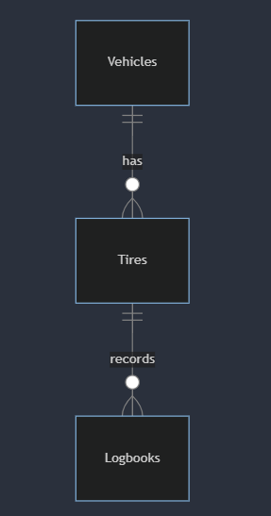

In this ER diagram:

* **Vehicles** entity represents different types of vehicles managed by Pavara Traders and Services.
* **Tires** entity represents tire-related information such as air pressure, tread depth, distance traveled, tire crossing patterns, and tire status.
* **Logbooks** entity represents logbooks specific to each vehicle type, recording tire-related information.

**Data Dictionary:**

The data dictionary provides detailed descriptions of each data element used in the system.

**Vehicles:**

**Type:** Entity

**Description:** Represents different types of vehicles managed by Pavara Traders and Services.

**Attributes:**

* **PM :** Identifier for Prime Movers.
* **RTGs :** Identifier for Rubber Tired Gantry Cranes.
* **TT :** Identifier for Terminal Transport
* **IT :** Identifier for Internal Transport
* **FS :** Identifier for Forklift Small
* **FL :** Identifier for Forklift Large
* **RS :** Identifier for Rings Tracker
* **PI :** Identifier for Prime Mover Internal

**Tires:**

**Type:** Entity

**Description:** Represents tire-related information.

**Attributes:**

* **airPressure:** Tire air pressure measurement.
* **treadDepth:** Measurement of tire tread depth.
* **distanceTraveled:** Distance traveled by the tire.
* **tireStatus:** Status of the tire (new or rethreaded).
* **tireBrand :** Brand of the tire
* **tirePosition :** Position in the vehicle where tire is currently using.
* **tireSerialNumber :** The Serial Number of the Tire.
* **tireCrossingPatterns:** Patterns of tire crossing.

**Logbooks:**

**Type:** Entity

**Description:** Represents logbooks specific to each vehicle type.

**Attributes:**

* vehicleTypeSpecificLogbooks: Logbooks recording tire-related information for each vehicle type.

**Normalization:**

In the provided ER diagram, the entities appear to be in at least the third normal form (3NF). Each attribute in the entities depends only on the primary key and there are no transitive dependencies.

**Explanation:**

The ER diagram illustrates the relationships between vehicles, tires, and logbooks. Each vehicle can have multiple tires, and each tire is associated with a logbook where tire-related information is recorded. This structure allows for efficient organization and retrieval of tire data for different vehicle types.

The data dictionary provides a detailed description of each entity and its attributes, aiding in understanding the purpose and usage of each data element in the system.

Normalization ensures that the database design is free from anomalies such as insertion, update, and deletion anomalies, by organizing data into well-structured tables and minimizing redundancy.

Overall, the data design ensures the efficient storage, retrieval, and management of tire-related information in the proposed system, supporting the goal of streamlining tire management processes for Pavara Traders and Services.